Day 3 Assignment 2:
Name: Mriganka Patra
Email: mriganka.patra@cognizant.com
Task 1:
Field | Description
Test Case ID | TC_SIGNUP_001
Objective | Verify user can successfully sign up with valid email and password
Steps | 1. Navigate to the signup page2. Enter valid email and password3. Click "Sign Up"
Expected Result | User is successfully registered and redirected to the welcome/dashboard page

Field | Description
Test Case ID | TC_SIGNUP_002
Objective | Verify system shows error when email field is left blank
Steps | 1. Navigate to the signup page2. Leave email field empty3. Enter a valid password4. Click "Sign Up"
Expected Result | Error message: "Email is required" is displayed, and signup is blocked

Field | Description
Test Case ID | TC_SIGNUP_003
Objective | Verify error message is shown for invalid email format
Steps | 1. Navigate to signup page2. Enter invalid email like user@.com3. Enter valid password4. Click "Sign Up"
Expected Result | Error: "Invalid email format" is displayed

Field | Description
Test Case ID | TC_SIGNUP_004
Objective | Verify error is shown when password field is empty
Steps | 1. Navigate to signup page2. Enter valid email3. Leave password blank4. Click "Sign Up"
Expected Result | Error: "Password is required" is displayed

Field | Description
Test Case ID | TC_SIGNUP_005
Objective | Ensure that duplicate email signup is blocked
Steps | 1. Navigate to signup page2. Enter an email that is already registered3. Enter password4. Click "Sign Up"
Expected Result | Error: "Email already exists" is shown

Task 2:
Test Data ID | Email | Password | Purpose
VD001 | user@example.com | Passw0rd! | Standard valid email and password
VD002 | john.doe123@mail.co.uk | J0hnDoe@123 | Valid with subdomain and special chars
VD003 | test.user+1@gmail.com | Test@2025 | Gmail aliasing, valid special char pwd
VD004 | alice_bob99@domain.io | A1iceBob$ | Underscore in email and strong pwd
VD005 | new.user@company.tech | MyPass@word1 | Valid TLD and special character usage

Test Data ID | Email | Password | Purpose / Reason for Invalidity
ID001 | (empty) | StrongPass1! | Missing email
ID002 | user@.com | Test1234 | Invalid domain format
ID003 | userexample.com | MyPass2025! | Missing @ symbol in email
ID004 | user@domain | Pass123 | No domain extension (.com, .net, etc.)
ID005 | valid@email.com | (empty) | Missing password
ID006 | duplicate@site.com | AnotherPass1! | Email already exists (simulate from previous signup)
ID007 | user@domain..com | Invalid@123 | Double dots in domain name
ID008 | user@domain!.com | ValidPass1 | Invalid character ! in domain
ID009 | test@site.com | 123 | Password too short (assume min 6–8 chars)
ID010 | test@site.com | password | Password lacks uppercase, number, or special character

Task 3:
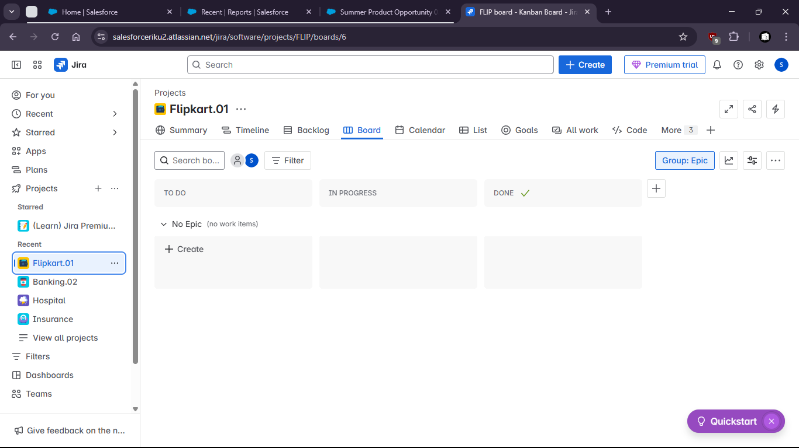

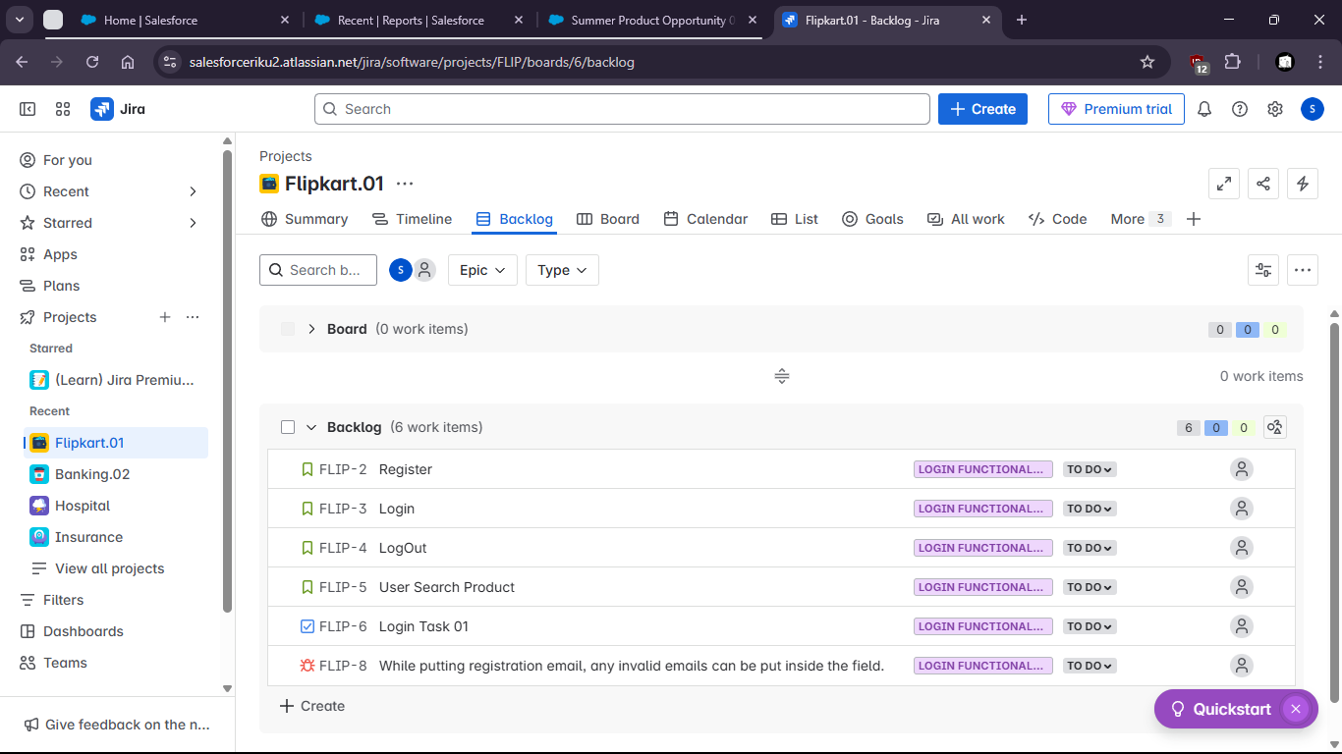
Task 4:

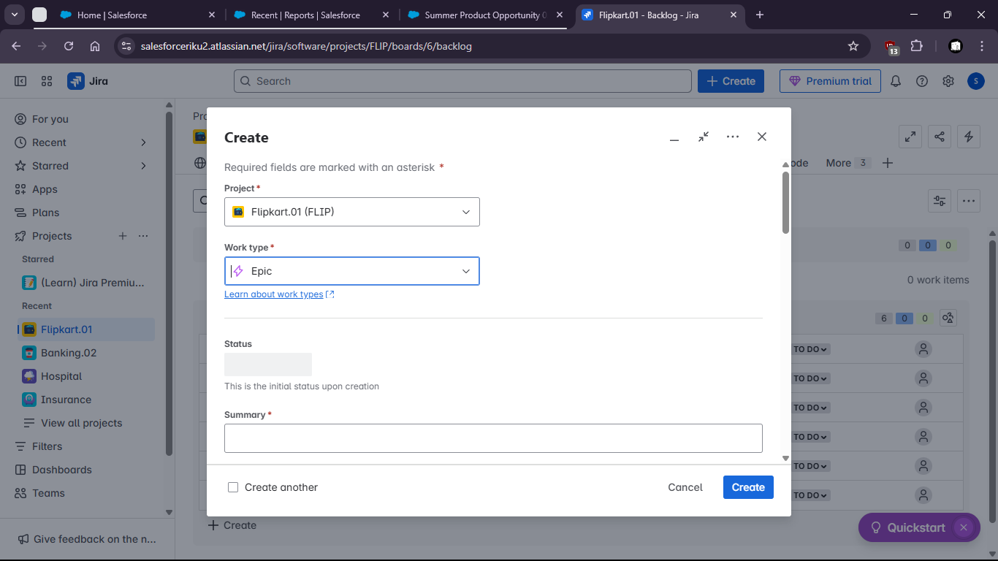
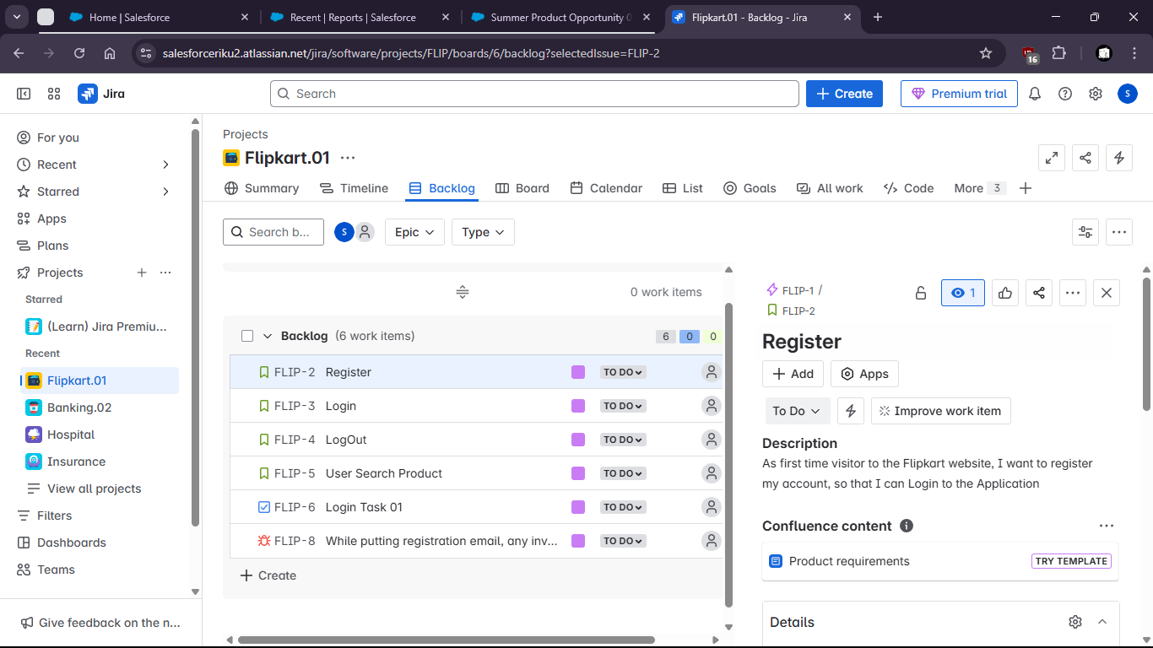

Task 5:
Area Covered | Status | Notes
Valid signup (happy path) | Covered | Test case ensures user can register with correct credentials
Empty email | Covered | Checks form validation for missing input
Invalid email format | Covered | Ensures email syntax is validated
Empty password | Covered | Validates password field is mandatory
Duplicate email | Covered | Ensures system prevents duplicate registrations
Password complexity | Partial | Not explicitly tested for different complexity requirements
Email case sensitivity | Missing | Not tested if User@Mail.com and user@mail.com are treated the same
Session/login post-signup | Missing | No coverage to check if user is automatically logged in after signup
Backend validation or API errors | Missing | No test for server-side error handling or unexpected responses

